Colorado Faculty Advisory Council (CFAC)
February 13, 2026, 9:00 am – 12:00 pm
Colorado Department of Higher Education
Remote Only
Join Zoom CFAC Meeting
Meeting ID: 934 0903 9717
Passcode: CFAC

CFAC AGENDA
- GREETINGS (Welcome – Melinda Piket-May and Attendance Christina Carrillo) (9:00 – 9:05 am)
- ADOPTION OF LAST MEETING’S MINUTES (9:05 – 9:10 am)
[See attached: CFAC November 14, 2025 NOTES.docx]
- DISCUSSION/ACTION ITEMS
  - CCHE – recent activity (Wayne Artis) (9:10 am – 9:25 am)
  - GEC - recent activity (Wayne Artis- Inst rep for PPSC) (9:25 am – 9:30 am)
  - Election of Vice-Chair; Candidate: Jess Gagliardi, Adams State (9:30 am – 9:35 am)
  - COLLEGE REPORTS (All) (9:35 am – 10:20 am)
- DHE UPDATES (10:20 am – 11:50 am)
  - Introduction of JB Holston, new CDHE Executive Director (9:00 am – 9:30 am)
  - New reduced credit bachelor’s degree - Brad Griffith, CDHE
  - Improving Statewide Transfer - Brad Griffith and Christina Carrillo, CDHE
  - Legislative Update – Brad Griffith and Christina Carrillo, CDHE
- CONTINUED OPEN DISCUSSION (All) (11:50 am – 12:00 pm)
    - Topics for next meeting?
    - Trump Administration on Impacts Higher Ed
    - Mutual Defense Compact
    - National Council of Faculty Senates
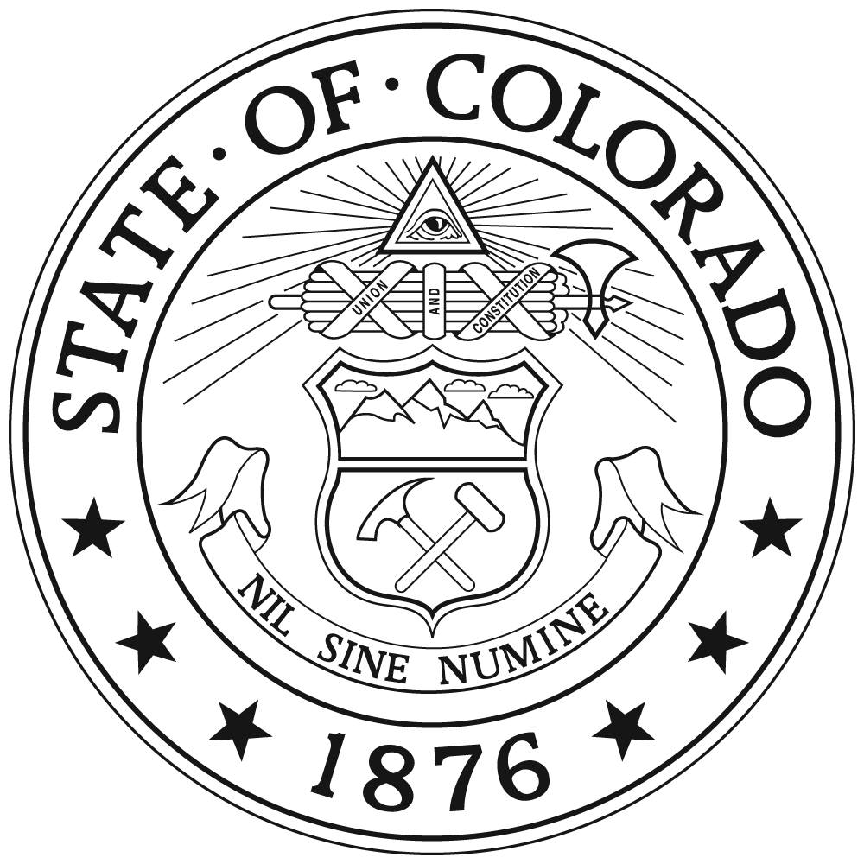
- ADJOURN (12:00 pm)

