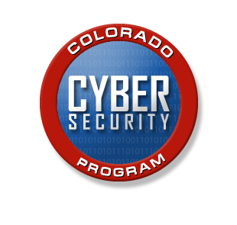

Incident Notification Reporting Form

STATE OF COLORADO

INFORMATION SECURITY OPERATIONS CENTER (ISOC)

INCIDENT NOTIFICATION FORM
Colorado Public Institutions of Higher Education
This incident report is forwarded to CDHE and the Office of Information Technology in accordance with the policies and procedures for reportable incidents as described in the institution’s IT Security Plan or Program.

 |  | Incident Date:  Institution:  Individuals Providing Report (Full Name)  E-mail address:  Phone:
  Impact/Effect/Consequence of Incident (Check all that apply)
  - Denial of service (including distributed)
  - Theft/loss of sensitive data (PII, student records, etc.)
  - Potential theft/loss of sensitive data (PII, student recs, etc.)
  - Shared System Compromise (app, file servers, etc.)
  - Desktop System Compromise
  - Physical Damage
  Cause of Incident (Check all that apply)
  - Account compromise (e.g., lost password)
  - Malicious code (e.g., virus, worm, Trojan)
  - Reconnaissance (e.g., scanning, probing)
  - Social engineering (e.g., phishing, scams)
  - Theft/loss of equipment or media
  - Unauthorized access (e.g., systems, devices)
  - Misuse of systems (e.g., acceptable use)
  - Technical vulnerability (e.g., 0-day attacks)
  - Physical vandalism (please describe below)
  - Unknown/Other (please describe below)
  Summary description of incident:
 |  | Report Date
 |  | Incident Number (ISOC Coordinator Only)
 |  | Current Incident Status

Incident Description

Incident Description

Incident severity (high, medium, or low)
Description of information compromised (or at risk)
Description of systems compromised

Networks and subnets involved/ affected

Other affected hosts/sites / information (include 3rd parties, local public health, other state agencies, etc.)
Description of actions taken in response to the incident

INFORMATION SECURITY OPERATIONS CENTER (ISOC -- ONLY):

Date /Time Reported to ISOC:

ISOC Incident Manager
Personnel Assigned:
Estimated Completion Date:
Actual Completion Date:
Hours required to complete:
Description of Action(s) Taken/Analysis/Containment: (Cause/sources if known, specific virus name, corrective action, etc.)
Date/Time Reported to Law Enforcement Agencies (if necessary):
Date/Time Reported to Other Sites:
Additional Action Taken:

Reporting an Information System Security or Cyber Incident

The OCS Information Security Operations Center (ISOC) is staffed to receive and disseminate timely information regarding network security vulnerabilities and threats in the State of Colorado. The ISOC will receive, analyze, and escalate reports to State agencies that their systems are being used to source or are being victimized by a threat vector.
The ISOC can be contacted at:
Email: ISOC@state.co.us
Phone: (303)764-7760
The Colorado Department of Higher Education will act as a communicator between the Colorado Office of Information Technology and the institutions of higher education regarding incident reporting.

In these matters please contact: Beth Bean
Director of Research and Information
303.866.2661 or beth.bean@dhe.state.co.us

